FINAL PROJECT
ON
ALZHEIMER DISEASE PREDICTION
BY
Lakshmi Prabha Swaminathan
Raghuram Parthasarathy
Harikrishna Ramakrishnan

Contents
- Problem Statement
  - Overview of disease progression
  - Overall project architecture
- Datasets
  - Neuropsychological Tests
  - Neurogenetic tests
  - MRI Images (Brain Scans)
- Data analysis
  - Neuropsychological Test – PCA
  - Neurogenetic Dataset (Clustering)
3.3 Neuroimaging – Computing size difference

1 Problem Statement
Alzheimer's is the most common form of dementia, a general term for memory loss and other intellectual abilities serious enough to interfere with daily life. Alzheimer's disease accounts for 60 to 80 percent of dementia cases. Alzheimer's has no current cure, but treatments for symptoms are available and research continues. Although current Alzheimer's treatments cannot stop Alzheimer's from progressing, they can temporarily slow the worsening of dementia symptoms and improve quality of life for those with Alzheimer's and their caregivers. Today, there is a worldwide effort under way to find better ways to treat the disease, delay its onset, and prevent it from developing.
1.1 Overview of disease progression
The symptoms of Alzheimer's disease worsen over time, although the rate at which the disease progresses varies. On average, a person with Alzheimer's lives four to eight years after diagnosis, but can live as long as 20 years, depending on other factors.
Changes in the brain related to Alzheimer's begin years before any signs of the disease. This time period, which can last for years, is referred to as preclinical Alzheimer's disease.
The stages below provide an overall idea of how abilities change once symptoms appear and should only be used as a general guide. They are separated into three different categories: mild Alzheimer's disease, moderate Alzheimer's disease and severe Alzheimer's disease. Be aware that it may be difficult to place a person with Alzheimer's in a specific stage as stages may overlap.

Overall Project Architecture

Neurogenetic Dataset Neuropsychological tests MRI Scans
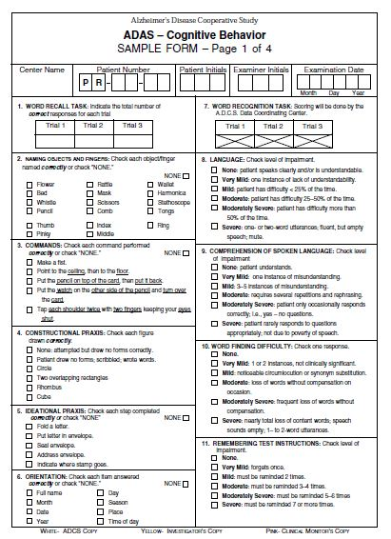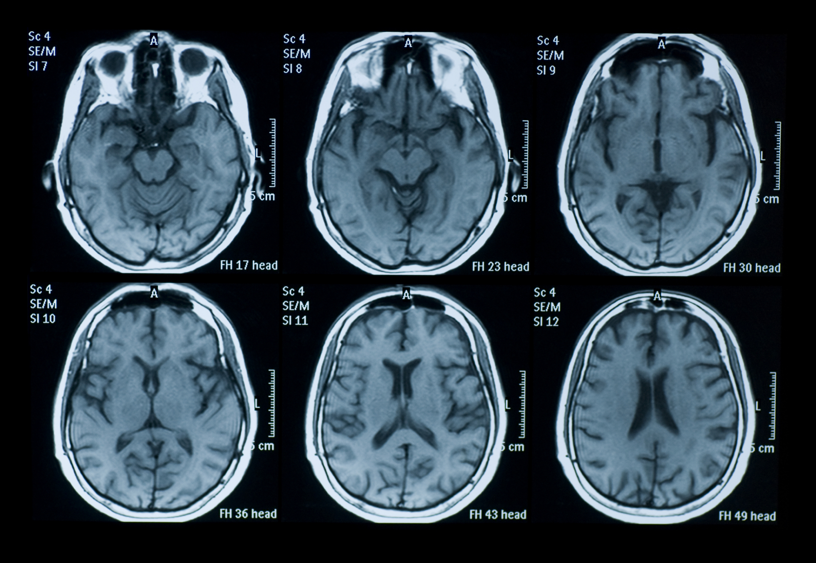
Machine Learning Algorithms
Binary Classification (Alzheimer/ No Alzheimer)
Supervised learning algorithms

Our objective is to analyze the neuropsychological tests, neurogenetic sets and brain scan images of patients and determine the presence of alzheimers in a patient. There are numerous neuropsychological tests taken by patients to determine the presence of Alzheimer. We determine which test is the best predictor of the disease. We perform principal component analysis on these datasets. We perform clustering in the neurogenetic dataset to determine the protein which contributes more to the disease. We process MRI images of patients and analyze the hippocampus region of the brain to determine presence/absence of Alzheimer.

2. Datasets
2.1 Neuropsychological set
We consider five of the tests in our data analysis.
MMSE (Mini Mental State Examination)
- Orientation, word recall, attention and calculation, language abilities, visual construction
- Scores range from 0 to 30. Less than 26 indicates Alzheimer's
FAQ (Functional Activities Questionnaire)
- It is an informant (caregiver) based measure of functional abilities
- The informant provides details of target person on 10 complex, higher order activities.
- Levels of performance are assessed and ranges from dependence to independence.
- Response for 10 questions recorded. Each question can take 0-3 value.
- Scores range from 0 to 30. A cut-point of 9 (dependent in 3 or more activities) is recommended.
- • Dependent = 3 • Requires assistance = 2 • Has difficulty, but does by self = 1 • Normal = 0
NPI (Neuropsychiatric Inventory)
- Administered by clinician to the caregiver. He is asked a set of questions he needs to answer. He should be aware of the behavior of the patient.
- It assesses 10 or 12 behavioral domains in dementia.

GDS (Geriatric Depression scale)
- Response for 10 questions recorded. Each question can take 0-3 value.
- • 1–4 No cause for concern • 5–9 Strong probability of depression • 10+ Indicative of depression
MOCA (Montreal Cognitive Assessment)
- The MoCA test is a one-page 30-point test administered in approximately 10 minutes.
- Attention, concentration and working memory are evaluated using a sustained attention task (target detection using tapping; 1 point), a serial subtraction task (3 points), and digits forward and backward (1 point each). Language is assessed using a three-item confrontation naming task with low-familiarity animals (lion, camel, rhinoceros; 3 points), repetition of two syntactically complex sentences (2 points), and the aforementioned fluency task. Finally, orientation to time and place is evaluated (6 points).

2.2 Neurogenetic set
Translocase of outer mitochondrial membrane 40 homolog (yeast), also known as TOMM40, is a protein which in humans is encoded by the TOMM40 gene.
Clinical significance
In humans, certain alleles of this gene have been statistically associated with an increased risk of developing late-onset Alzheimer's disease. One study has found that TOMM40 risk alleles appears twice as often in people with Alzheimer's disease than those without it.
TOMM40 Allele 1 and TOMM40 Allele 2 was clustered to identify better range distribution.

2.3 MRI Images (Brain Scans)
When a person is affected by Alzheimer, the hippocampus region of the brain degenerates. Alzheimer patients suffer from memory loss because the hippocampus region of the brain keeps track of all memories. In the neuroimaging dataset, we identify the hippocampus region of the brain and indirectly measure its degradation.

3. Data Analysis
3. 1 Neuropsychological Test – PCA
We perform this to determine the significant test of the 5 tests
The tests we consider are
- NPI
- FAQ
- MMSE
- CDR
- MOCR
- GDS
We need to aggregate the scores for each of the tests before we perform principal component analysis.
Net score over a period of time = (Score 1 + Score 2+…+Score n)/Day Difference
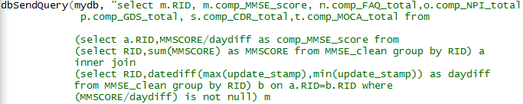
We perform this for each of the test and join the aggregated data for all the tests
This is given as input for principal component analysis.
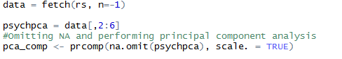

  - Neurogenetic Dataset (Clustering)
We perform k means clustering on the neurogenetic dataset to determine the distribution of protein in the two genes (TOMM40_ADNI1 and TOMM40_ADNI2)

Result:
We determine that ADNI2 is the dominant protein after performing k means clustering.

3.3 Neuroimaging – Computing size difference
Calculating hippocampus size difference
Steps involved:
- Neuroimage segmentation
- Laplacian transform to normalize image
- Detection of edges
- Detection of corners with the edges already detected
- Calculation of size difference

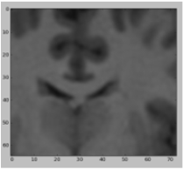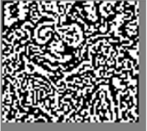
- Image segmentation 2. Laplacian Transform 3. Edge detection


Computing size difference
4. Corners detection
File processing for size difference computation
- The datasets of the MRI scans have been downloaded from http://www.oasis-brains.org/ (http://www.oasis-brains.org/app/template/Tools.vm;jsessionid=35D9DD2D26127CF9EC731915BD6B698E#ftp)
- We download the cross sectional view dataset (total of 12 disks)
- We write a python code to extract the required processed MRI images to another folder so that we can perform image processing on them
- We extract only those images where a patient has 2 MRI scans (to compute size difference)
- We run the python code that performs the image processing to store the size difference in the database.

Prediction of Alzheimer disease
We use the output of the neuropsychological, neurogenetic and neuroimaging dataset to finally predict the presence or absence of Alzheimer disease. This is a supervised learning problem.

 | Neural Networks | Random Forest | Bayes Point Machine
True Positive | 431 | 431 | 431
False Positive | 16 | 11 | 16
True Negative | 0 | 5 | -
Accuracy | 96.4% | 97.5% | 96.4%
Error | 3.6% | 2.5% | 3.6%
Precision | 96.4% | 98.7% | 98.2%

Training Model
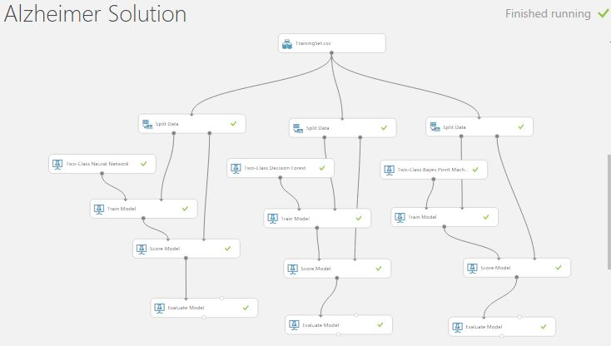

Prediction
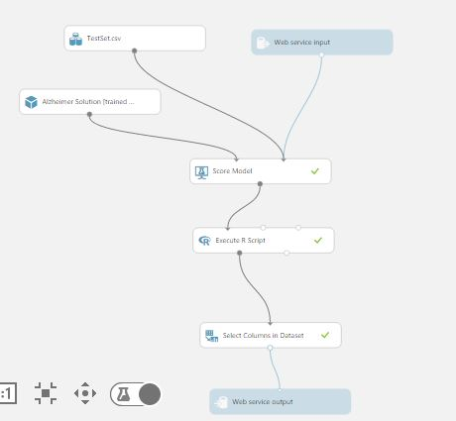

3.3 Neuroimaging – Computing size difference
Calculating hippocampus size difference
Steps involved:
- Neuroimage segmentation
- Laplacian transform to normalize image
- Detection of edges
- Detection of corners with the edges already detected
- Calculation of size difference

- Image segmentation 2. Laplacian Transform 3. Edge detection

Computing size difference
4. Corners detection

File processing for size difference computation
- The datasets of the MRI scans have been downloaded from http://www.oasis-brains.org/ (http://www.oasis-brains.org/app/template/Tools.vm;jsessionid=35D9DD2D26127CF9EC731915BD6B698E#ftp)
- We download the cross sectional view dataset (total of 12 disks)
- We write a python code to extract the required processed MRI images to another folder so that we can perform image processing on them
from PIL import Image
import sys
import cv2
import numpy as np
import matplotlib.pyplot as plt
import MySQLdb
import os.path

def compSizediff(path1,path2):
db = MySQLdb.connect(host="127.0.0.1", # your host, usually localhost
user="root", # your username
passwd="root", # your password
db="alzheimer_solution", port=3306,unix_socket="MySQL")

cur=db.cursor()
cur.execute("DROP TABLE TEMP_PATIENT_MRISCAN")
cur.execute("CREATE TABLE TEMP_PATIENT_MRISCAN AS SELECT * FROM PATIENT_MRISCAN WHERE 1=2")
path1.replace('\\' ,'/')
path2.replace("\\","/")

if os.path.exists(path1)==True & os.path.exists(path2)==True:

img = cv2.imread(path1,cv2.IMREAD_COLOR)

hipp_face = img[40:105,58:131]
wname = 'MRI_pat_scan_1.jpg'
cv2.imwrite(wname,hipp_face)
#img = cv2.imread('MRI_part.jpg',cv2.IMREAD_COLOR)

#cv2.imshow('image',img)

#cv2.waitKey(0)

#cv2.destroyAllWindows()

frame = cv2.imread(wname,cv2.IMREAD_COLOR)
laplacian = cv2.Laplacian(frame,cv2.CV_64F)
edges = cv2.Canny(frame,100,150)
cv2.imshow('original',frame)
cv2.imshow('laplacian',laplacian)
cv2.imshow('edges',edges)
cv2.imwrite(wname,edges)
mripart=cv2.imread(wname)
gray = cv2.cvtColor(img, cv2.COLOR_BGR2GRAY)
gray = np.float32(gray)

corners = cv2.goodFeaturesToTrack(gray,50,0.01,10)
corners = np.int0(corners)

a,b = 0,0

for corner in corners:
x,y = corner.ravel()
cv2.circle(mripart,(x,y),2,255,-1)
str1=str(a)
str2=str(b)
#+" "+chr(y)+","+chr(a)+" "+chr(b)
a,b = x,y

#pts=np.array([])

str3="GeomFromText('LINESTRING("+str(x)+" "+str(y)+","+""+str1+" "+str2+")')"
str4="insert into temp_patient_mriscan values(1,"+str3+")"
print str4
cur.execute(str4)

img = cv2.imread(path2,cv2.IMREAD_COLOR)

hipp_face = img[40:105,58:131]
wname = 'MRI_pat_scan_2.jpg'
cv2.imwrite(wname,hipp_face)
#img = cv2.imread('MRI_part.jpg',cv2.IMREAD_COLOR)

#cv2.imshow('image',img)

#cv2.waitKey(0)

#cv2.destroyAllWindows()

frame = cv2.imread(wname,cv2.IMREAD_COLOR)
laplacian = cv2.Laplacian(frame,cv2.CV_64F)
edges = cv2.Canny(frame,100,150)

cv2.imshow('original',frame)
cv2.imshow('laplacian',laplacian)
cv2.imshow('edges',edges)
cv2.imwrite(wname,edges)

mripart=cv2.imread(wname)
gray = cv2.cvtColor(img, cv2.COLOR_BGR2GRAY)
gray = np.float32(gray)

corners = cv2.goodFeaturesToTrack(gray,50,0.01,10)
corners = np.int0(corners)

a,b = 0,0

for corner in corners:
x,y = corner.ravel()
cv2.circle(mripart,(x,y),2,255,-1)
str1=str(a)
str2=str(b)
#+" "+chr(y)+","+chr(a)+" "+chr(b)
a,b = x,y

#pts=np.array([])

str3="GeomFromText('LINESTRING("+str(x)+" "+str(y)+","+""+str1+" "+str2+")')"
str4="insert into temp_patient_mriscan values(1,"+str3+")"
print str4
cur.execute(str4)
db.commit()
res = cur.execute("SELECT max(GLENGTH(patient_scan))-min(GLENGTH(patient_scan)) as size_diff FROM temp_patient_mriscan GROUP BY patient_id")
row = cur.fetchone()
db.close()
return row

- We extract only those images where a patient has 2 MRI scans (to compute size difference)
- We run the python code that performs the image processing to store the size difference in the database.

Data Visualization:
